Infrastructure is part of the capital stock of an economy and consists of inputs that enter into the output of the production of other governmental sectors. The importance of infrastructure and its position in relation to other sectors including socioeconomics and politics is high and can be a determining factor in the development and success of a country (Hofmeir, pg. 6). One country that has played around with large infrastructure development is Tanzania.
One of the biggest contributors to Tanzania’s large infrastructure development is its commitment to transport systems. The development of a transport system is often regarded to be of importance for the process of economic and social growth of a country. Therefore, the participation in transport activities and implementation of transport infrastructure can be seen as one of the essential basic functions that are typical for the existence of a successful country. In fact, in 1975, the United Nations identified Tanzania as one of the twenty-five least developed countries (Bomani, Paul, and Douglas Ensminger, 1975). However, currently Tanzania is East Africa’s second largest economy and is continuing to grow as the government supports the growth and improvement of transport infrastructure (Bomani, Paul, and Douglas Ensminger, 1975).
Since 1960, when Tanzania was founded, its transportation systems have evolved. As of now, there exists transportation through road, rail, air, and water networks. One of the most widely used mediums of transportation is through roadways and the development of these roadways continues to increase and help the economic status of the country (Hofmeir, pg. 7). In 2010, the Tanzania government proposed the development of a 385- kilometer commercial road that would stretch across the northern part of the Serengeti National Park. This project would be commonly known as the Serengeti Highway (see Figure 1) and would have both positive and negative implications on the development of the country (the name of the actual road project is Natta-Mugumu-Tabora B-Kleins Camp-Loliondo or NMKTL) (Casadana, 2014).
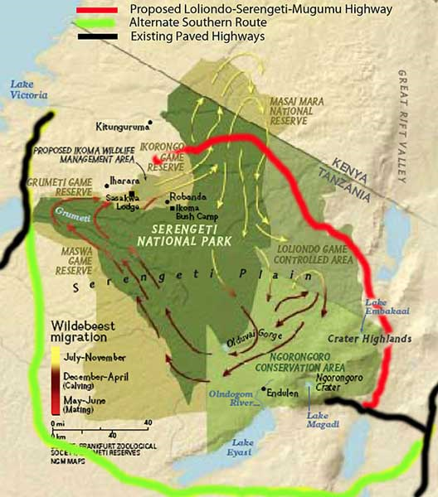
Figure 1: “Serengeti Highway”
https://baobabtravel.wordpress.com/2011/04/06/serengeti-highway-proposal-an-overview/

The Tanzanian government’s main goal for constructing the proposed Serengeti Highway would be to link the overcrowded Lake Zone regions surrounding Lake Victoria with other commercial areas in Tanzania (Moyer, 2012). Currently, more than 5,000,000 residents make up the Mara and Mwansa Regions of Tanzania making it the second largest urban population in Tanzania after Dar es Salaam. The existing infrastructure and roads connecting the Lake Zone regions to other areas of Tanzania are poor and sometimes they are even inaccessible during the wet season. In 2005, the Tanzanian government suggested constructing a paved road from Mto wa Mbu to Natta in the Serengeti District. Although a dirt road currently exists between Mto wa Mbu and the Lake Zone, it is in poor condition (Casadana, 2016). As a result, the government’s primary reasoning for the construction and upgrading of new roads are due to commercial interest, an increase in jobs, and improved access between different regions of Tanzania.
The proposal of the Serengeti Highway sparked much local, national, and international apprehension. Major concerns were made toward the project mainly due to the impact it would have on Serengeti National Park. Many conservationists expressed fear that the project would interfere with the great Migration of wildebeest, zebra, and antelope that annually pass through northern Serengeti National Park. Other environmental impacts were also brought up including: increased poaching due to more accessible roads, the introduction of invasive species, increased road kill, habitat loss and fragmentation, and further threats to the already endangered species.
According to the Tanzania National Roads Agency (TANROADS) and African Development Bank Group (ADB), the proposal of the new Serengeti Highway called for a full Environmental and Social Impact Assessment (ESIA), because it is considered as a Category 1 project (United Republic, 2010). Category 1 projects are “likely to induce important adverse and irreversible environmental and/or social impacts, such as the displacement of more than 200 people (United Republic, 2010).” A full ESIA and an Environmental Management Plan (ESMP) are required, and a Resettlement Action Plan (RAP) may apply (United Republic, 2010). From looking at the research made by the ESIA report, I would suggest that the Serengeti Highway project would bring economic and social gain to Tanzania at the cost of negative ecological impacts. However, I would still suggest that the economic and social gains do not outweigh the potential risk of the proposed highway. Additionally, from looking at similar projects in different national parks, it can be seen how this project may negatively and positively affect the environmental/ecological aspects and socioeconomic status of Tanzania.
Previously stated, the Tanzanian government’s main purpose of constructing the Serengeti Highway was to increase commercial activity and to provide more economical and social benefits to its citizens. As a result, examining potential social and economic impacts of this project is essential to see if it can successfully carry out its stated goal.
Typically, improved infrastructure and transport systems often lead to increasing economic benefits of a country. The Serengeti Highway project would link two key economical regions, Arusha and the Lake Zone. This would reduce the friction of distance and allow for the improvement of movement of people and goods across areas (Haazen, 2012). Currently, nearly 80% of inhabitants in the Ngorongoro and Serengeti districts engage in some type of agriculture and/or livestock activities. In Ngorongoro, the Maasai only practice small-scale farming and more than 80% of their economic activity is livestock keeping. In the Serengeti District, most villages focus on farming, which makes up 50-60% of their economic activity (United Republic, 2010), in combination with livestock keeping, which ranges from 15-25% of economic activity (United Republic, 2010). For both districts, all other economic activities and formal employment, is less than 10%, except for in towns such as Mugumu and Loliondo where retail businesses and district and local government agencies are up to 10% each in terms of economic activity (see figure 2) (Haazwn, 2012). With the execution of the Serengeti Highway, it is shown that livestock keepers would be able to access more areas of each district to sell their livestock. Other socioeconomic benefits from the project would include: employment opportunities, income from newly leased land, a boost to tourism due to easier access of the Serengeti, more investment opportunities, and improved regional links which reduces travel times.
The argument that the road itself will help alleviate social problems and bring about economic gain is questionable. Some of the justifications made for executing the project can be counterargued and proven to be insufficient. For example, the ESIA report suggested the Serengeti Highway would give residents easier access to HIV/AIDS information and healthcare. However, it fails to point out the potential danger of the spread of communicable diseases like HIV/AIDS (United Republic, 2010). The World Bank and other agencies have already recognized that increased transport leads to an increase in the prevalence of HIV/AIDs and other diseases, especially in rural largely uneducated societies, such as in Ngorongoro and Serengeti (United Republic, 2010). In addition to the potential risk of the rise in diseases, constructing the Serengeti Highway would also pose a security threat to some regions of the country.
In Tanzania, we learned that it is often unclear as to whose land belongs to who, therefore land conflicts already exist. The Serengeti Highway could expose more opportunities to claim land, which would give elitist and foreign investors more opportunities to buy it and exploit residents even more by benefitting economically (typically, none of the money ever goes back to the residents living in these communities). Therefore, the argument made that investments would increase is false, because these investments would only come from outsiders rather than inhabitants of the land (Sinclair 2008). Other security issues that could take place include clan and tribal conflicts. These conflicts are already an issue in both the Serengeti and Ngorongoro Districts and often include violence with the use of illegal firearms and death (Hooker, 2014). As a result, it can be suggested that increased transport could intensify these conflicts and lead to more security threats. Economically, an increase in security threat would lead to an increase in government spending on police presence to mitigate this negative impact.
The failure of the potential positive socioeconomic impact that the Serengeti Highway could have can be asses by looking at the socioeconomic impact of roadway projects in other parks. For example, the Trans Kalahari Highway was constructed to connect areas of Botswana with Namibia and South Africa. One part of this highway cuts through the Kgalagadi Transfrontier Park and between two of Botswana's larger reserves, the central Kalahari game reserve and the Kalahari Gemsbok National Park (United Republic, 2010). The Namibian government argued that the socioeconomic results of this road would increase traffic safety, open more job opportunities, and increase tourism; however, none of these assertions became reality.
The socioeconomic situation has not changed since the road was constructed and the unemployment rate has not improved. In terms of road safety, the number of accidents involving animals, both domestic and wild, has doubled from 18 % to 36% (United Republic, 2010). Comparing the outcome of the Trans Kalahari Highway to the Serengeti Highway gives great insight to what can potentially occur if this project takes place. Although all the Trans Kalahari Highway’s shortcomings are not the direct result of the roadway, it shows that the expansion of new roadway systems through conserved areas should be viewed carefully.
In addition to socioeconomic effects, a Serengeti Highway would pose threats to the environment as well. Currently, wildlife in the Serengeti is protected within the park and remain separate from human activity. The specific habitats surrounding the Serengeti is crucial to the survival of many of these animals and any alteration in it could greatly diminish its populations. In 2005, many conservationists worked alongside the Tanzanian government to develop and implement a 10-year management plan to protect Serengeti National Park. The plan highlights specific areas of the park as “highly sensitive” that were considered a critical habitat for endangered species (United Republic, 2010). Ironically, the northern area, where the Serengeti Highway was proposed to be built, is considered as one of these “highly sensitive” areas. The importance of maintaining and protecting these areas is high and needed, therefore constructing a road through this specific area directly opposes the objectives and goals of the Serengeti 10-year management plan.
Another threat to the environment that the Serengeti Highway makes is passing through the wildebeest migration route (often known as the Great Migration). During this migration, wildebeest and a variety of other animals travel more than 500 kilometers from southern Serengeti to northern areas near Masai Mara in Kenya (Katala, 2000). During the dry season, this area is the main water source available. As a result, if this migration path were to be blocked or altered by the Serengeti Highway, these animals would be unable to reach these water sources. This could reduce wildebeest population from 1.3 million to 200,000 and the animals would be forced to remain in the south. This would cause an overconcentration of the number of animals in the area and would lead to overgrazing, therefore declining the population of different wildlife due to the lack of a prominent food source. A decrease in the number of wildebeest and other wildlife could also serve potential harm to the land. The decrease in grass-feeding animals would result in a greater amount of grass being uneaten, therefore leaving the park more vulnerable to fires (Katala, 2010).
An improved transport system would also increase the rate of collisions with animals. As traffic increases, the need for other infrastructure, such as fences, would come into play. Fences would provide protection to wildlife and human being from colliding with one another, however, constructing fences means bisecting the habitat of these animals. In addition to the loss of animals via traffic collisions, mortality rates would increase due to poaching. The access to animals would become more convenient and would make it easier to transport illegal goods cross country. It is also important to note that a Serengeti Highway would make it easier to introduce invasive plant species and diseases into the environment. Plants, like the Chromolaena or Opuntia, are known to grow in areas near major roads (United Republic, 2010). If introduced to the Serengeti, they could thrive off the destruction of the current ecosystem and would have irreversible effects on biodiversity life. In reference to disease, transportation of livestock would increase making it more simple to spread diseases such as rinderpest (a disease spread to wildebeest from cattle) which could be another potential hazard to the population of animals in the Serengeti (Haazen, 2012).
By looking at the roadways in Etosha National Park, located in Namibia, environmental effects a result of these infrastructure systems can be predicted. Etosha national Park had become enclosed by an 850-kilometer game fence due to the outbreak of foot and mouth disease (United Republic, 2010). Before the fence was built, the area saw large and growing numbers of animals migrating into the park. Upon completion of the fence, Etosha saw a huge decrease in its wildlife population and diversity by nearly 40%. The wildebeest population in Etosha dropped 85% from a population of 25,000 to only 2,600. Additionally, the lack of movement among animals within Etosha also led to increased incidences of diseases like rinderpest and anthrax (Haazen 2012).
Along with Serengeti National Park, many national parks around the world have had to make difficult decisions when socio-economic and political interest collide with conservation aims and the need to maintain biodiversity. Nonetheless, these variables are often interlinked and good decision making must come into play when recognizing the potential risk factors large infrastructure may play in conservation. The impact that the proposed Serengeti Highway will have on biodiversity and wildlife is impossible to calculate, but from the ESIA report it is well supported that negative impacts to the environment will take place. Additionally, some economic and social gains can be made with the implementation of the Serengeti Highway, but they are not guaranteed. It all comes down to assessing whether the potential gains outweigh potential risk. In my opinion, an alternative to both these ideas would be to continue the project by mitigating the potential negative factors that would affect the environment. There is an overwhelming need to decrease the overflow of traffic going through the Serengeti, so completely ignoring the issue is not an option and neither is contributing to an already weakening ecosystem.
If this means that it would cost more to come up with an alternate Serengeti Highway that would avoid the precious parts of the ecosystem, then I believe it would be worth it. Research on alternate routes has already taken place and a “southern” route in place of the original Serengeti Highway has been proposed (United Republic, 2010). This route (see Figure 2 – the green path shows the alternate route) would completely bypass Serengeti National Park altogether and would provide economic benefits while keeping the current ecosystem and levels of biodiversity intact. Choices should not be made between people and nature. People and natures should find ways to work together while benefiting from one another equally. Thus, there is no need for Tanzania to sacrifice its environment and wildlife in exchange for income or heritage.
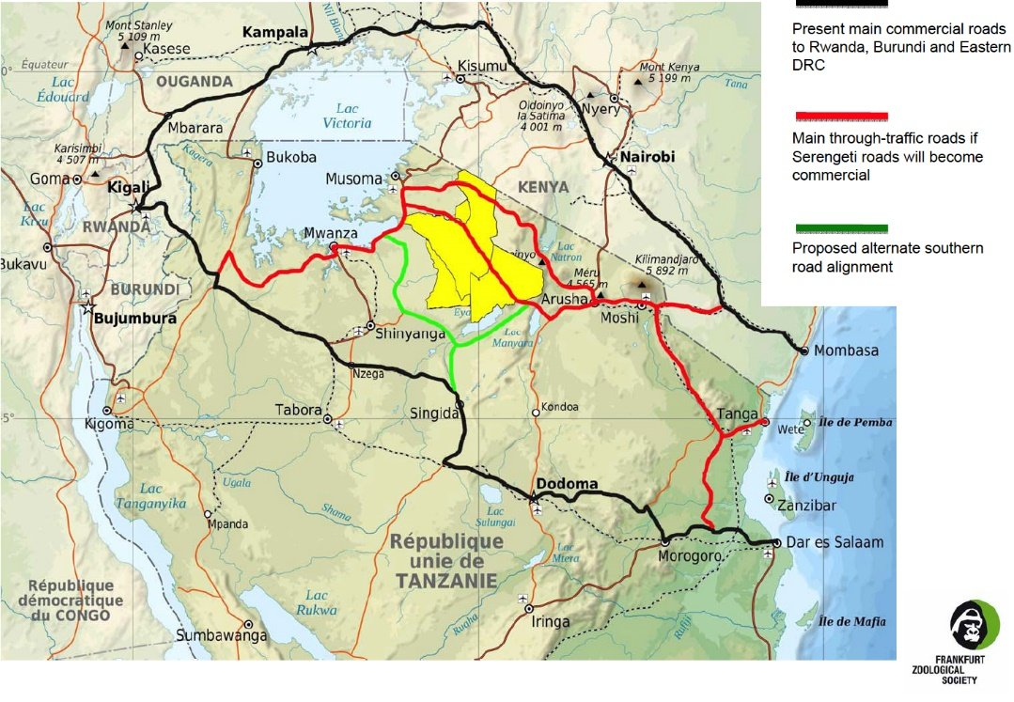
Figure 2: “Alternate Route”
http://serengetiwatch.org/wp-content/uploads/2010/06/fzs_so_higw.jpg

My Experience Summary:
The long rides throughout Tanzania really inspired me to write this paper. Through the various cities, villages, and towns we traveled through I could see how road development varied. Sometimes we would be on paved roads, while at other times the roads were just dirt roads. Through the articles and my own speculation, I wanted to study how road development, specifically in Tanzania, affected some aspects of the country. After a short conversation with Paul, I decided to specifically focus on the proposal of the Serengeti Highway and how it would have affected this area. I narrowed down the categories to the environment, society, and economy and drew my own hypothesis as to whether I believed road development would hurt or help that specific category. Before doing research, I assumed road development would boost the economy, threaten the environment and would boost society. From my research, I learned that this project has been in the works since the early 2000’s. The project not only included the development of new roads in Tanzania, but also included upgrading many of the existing roads from gravel to tarmac or butimen. I was unaware of the amount of thought and consideration that also went into this project. An assessment (ESIA) was conducted by the African Development Bank Group to evaluate the type and scale of potential biodiversity, social, political, and economic impacts that business proposals or projects may cause. They studied different areas where similar projects had taken placed and studied how the implementation of the Serengeti highway would affect biodiversity and the environment.
Studying abroad in Tanzania is my most valuable experience thus from in my life. From this experience, I was able to travel back to my “home” continent and learn about my favorite subject with knowledgeable professors and students. Additionally, being emerged in the culture was priceless. I was extremely happy that the professors took us to two extreme locations (the bomba and the cities) to see how Tanzania can vary geographically, economically, and socially. One of my favorite activities was having interviews with Maasai men and women. Sometimes I found it frustrating to communicate with them (especially when they would ask about my race/ethnicity/nationality), because I usually had to always have a faculty member translate for me (not that that was a bad thing, but I defiantly feel like some of my interpretation was lost through translation). Another one of my favorite activities was visiting Wasso Hospital in Loliondo. It helped to dismantle certain things I assumed about Africa and Tanzania. For example, I thought HIV/AIDS would be the greatest medical problem in the region, but it’s not even in the top 3. The top 3 diseases regarded diseases via animal to host transmission and malnutrition problems.
From embracing Maasai culture to camping in the middle of the safari to lodging in the cities, I learned a lot of myself and the subject of ecological health from studying abroad in Tanzania. I still don’t believe that I can accurately communicate my experience without physically being there again, but going to Tanzania was worthwhile and I will do it again.
**I also kept a day-to-day blog while on my study abroad trip, it can be access here.

Bibliography
Bomani, Paul, and Douglas Ensminger. "Tanzania's Road to Development: Bringing Development to the People." Ekistics 40.237 (1975): 111-14. Web. 12 July 2016.
Casanda, Peter. "An Overview of the Road Infrastructure in Tanzania | Lexology." An Overview of the Road Infrastructure in Tanzania. Globe Business Media Group, 1 Sept. 2014. Web. 12 July 2016.
Haazen, Dominic. "Making Health Financing Work for Poor People in Tanzania." World Bank Studies. The World Bank, 2012. Web. 14 July 2016.
Hofmeier, Rolf. Transport and economic development in Tanzania; with particular reference to roads and road transport. München: Weltforum Verlag, 1973. Print.

Hooker, Lucy. "Worries over New Roads in Tanzania's Serengeti." BBC News. N.p., 17 Jan. 2014. Web. 14 July 2016.
Katala, J., and T. Toole. "Road management systems–The development of the Road Mentor System in Tanzania." Proceedings of Tanzanian Annual Roads Convention. 2000. Web. 12 July 2016
Moyer, Jacob. "Tanzania Delivers Road Construction Boost." World Highways. Route One Publishing, 20 Sept. 2012. Web. 14 July 2013.
Sinclair, ARE and Craig Packer, Simon Mduma, et al. “Serengeti III: Human Impacts on Ecosystem Dynamics.” Chicago University Press. Web. 15 July 2016.
The United Republic of Tanzania. “Environmental and Social Impact Assessment.” National environmental Management Council. October 2010. Web. 14 July 2016.

